Experiment No : 01
Experiment Name : How To Set Up Linux Ubuntu.(17.10)

What is Linux operating system?

Ans:
Linux is a Unix -like, open source and community-developed operating system for computers, servers, mainframes, mobile devices and embedded devices. It is supported on almost every major computer platform including x86, ARM and SPARC, making it one of the most widely supported operating systems.

We use linux operating system because:
- Linux is Free an Open Source.
- Linux can run low Hardware machines too.
- Well supported.
- Lots of Flavors.
- Good security.
Experiment Setup : Here we will implement Linux Ubuntu 17.10 . We will do Dual-Boot Linux ubuntu 17.10 and Windows 10.
The install process is given below.
5 steps to Dual-Booting:
- Download the Linux Mint operating system (in an iso file format) from Linux ubuntu website.
- Downloads Rufus (a program for creating boot-able USB flash drives).
- Use Rufus to create a boot-able USB flash drive and copy Linux Mint onto it.
- Restart your pc and load Linux Ubuntu from your USB flash drive.
- Run the Mint installation wizard to install Linux Mint 18.2 along-side Windows 10 (64 bit).
Step 1:
Download Linux Ubuntu:
we will Download Linux ubuntu operating System in an iso file format from linux ubuntu website. http://linuxubuntu.com/
We will dowload it so that during downloading Linux mint no error is occured.
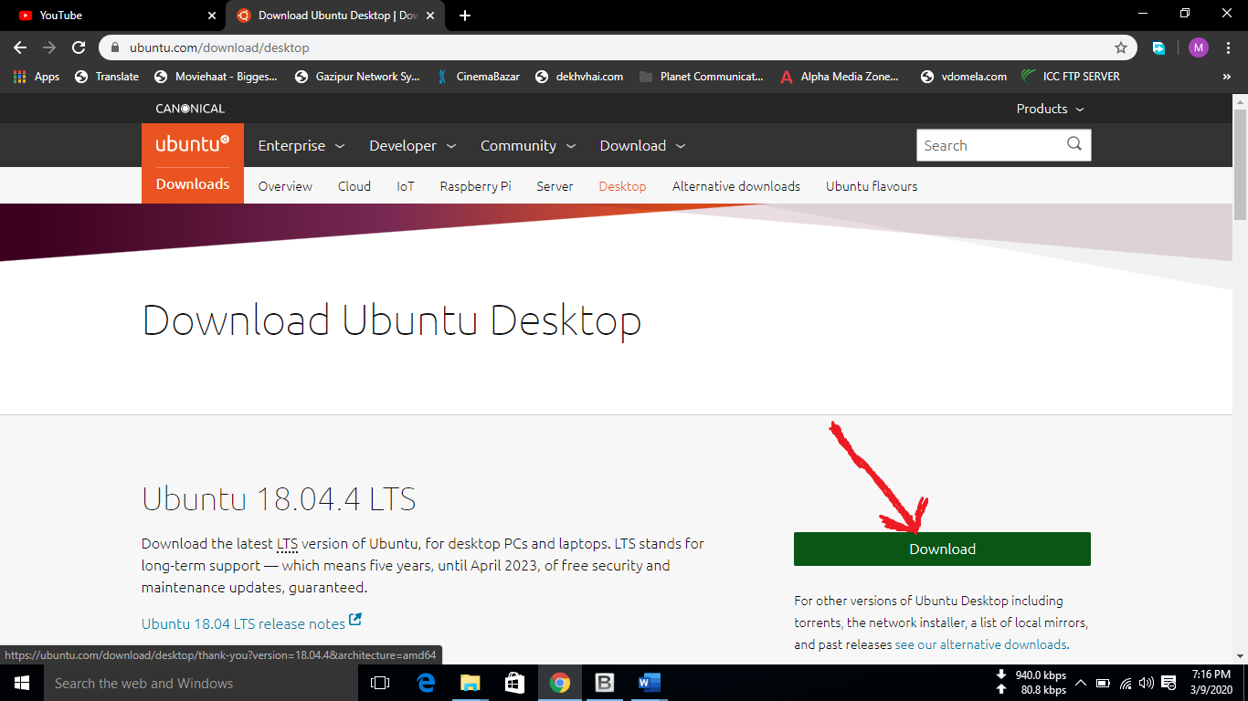
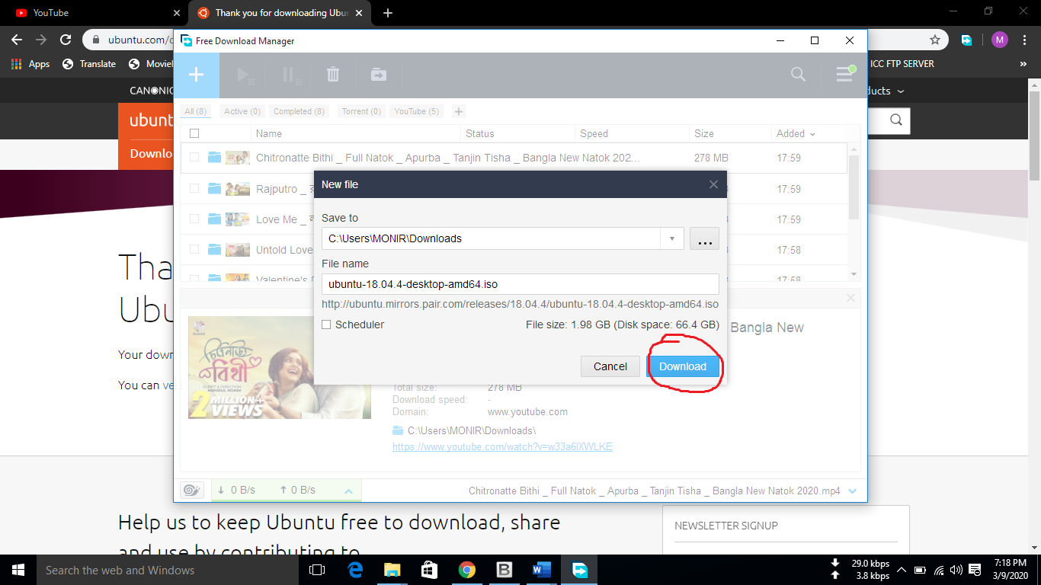
STEP 02 and 03:
We will download and install Rufus.
Befor installing Rufus connect a USB flash drive with pc.
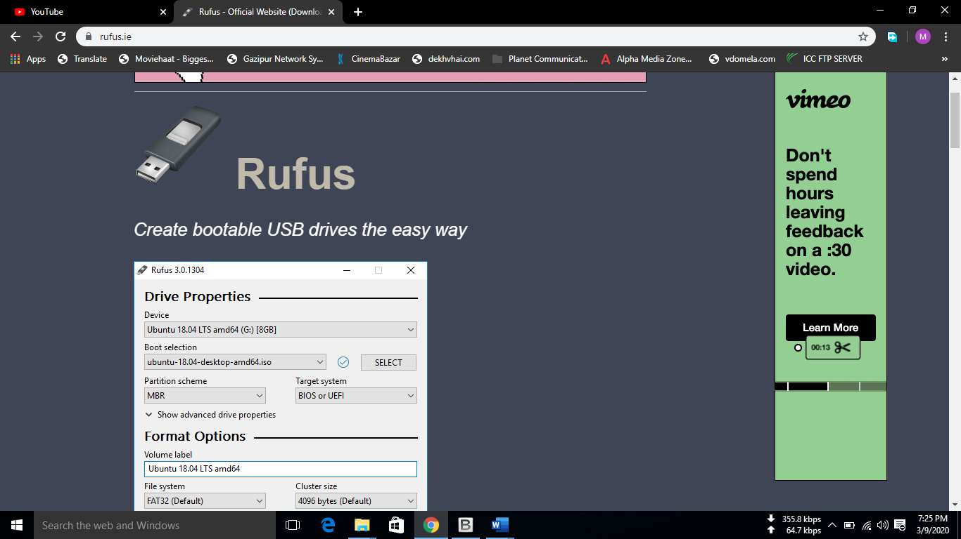
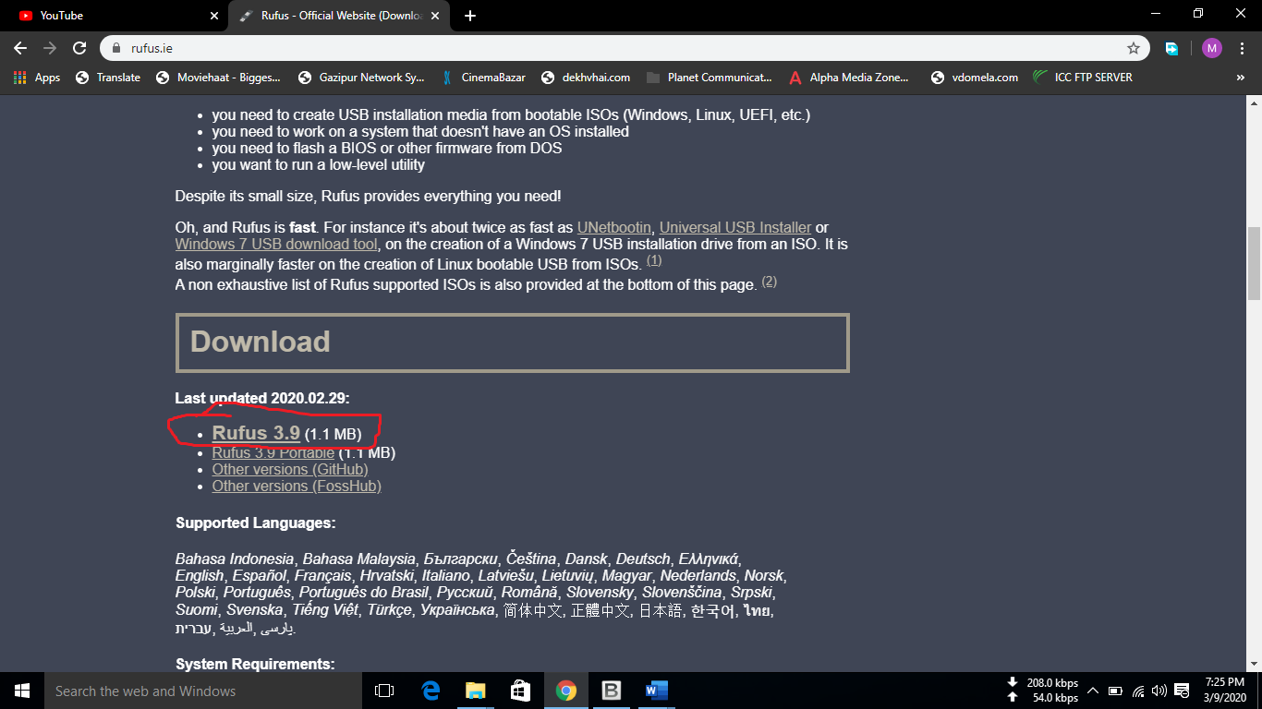
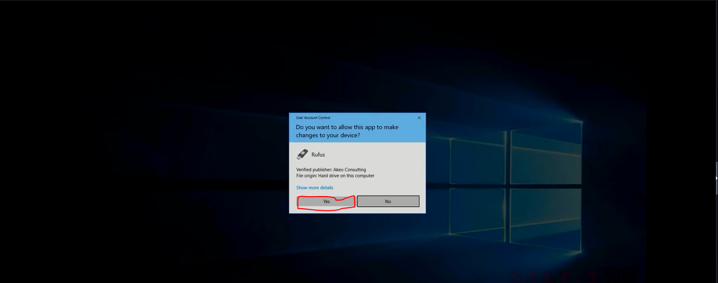
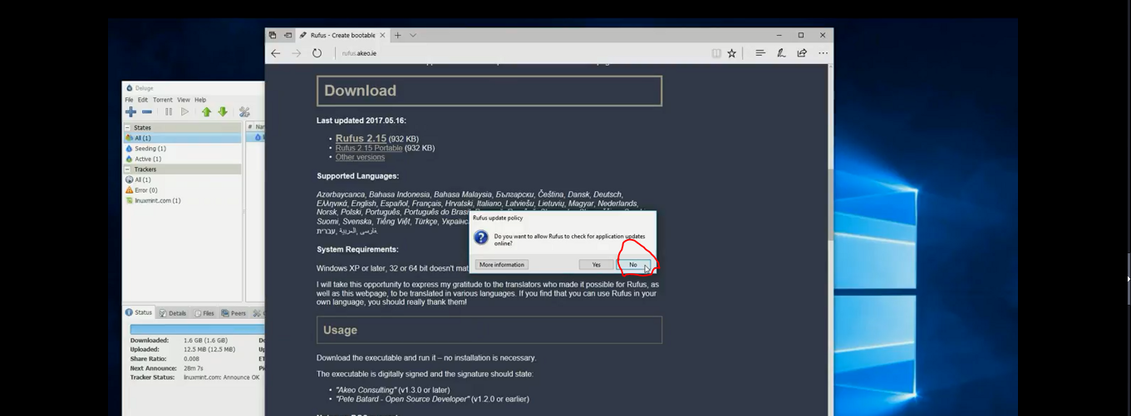
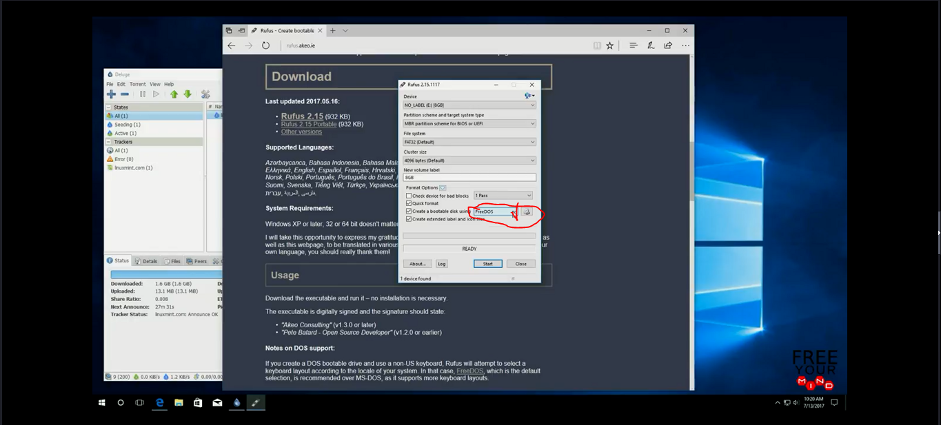
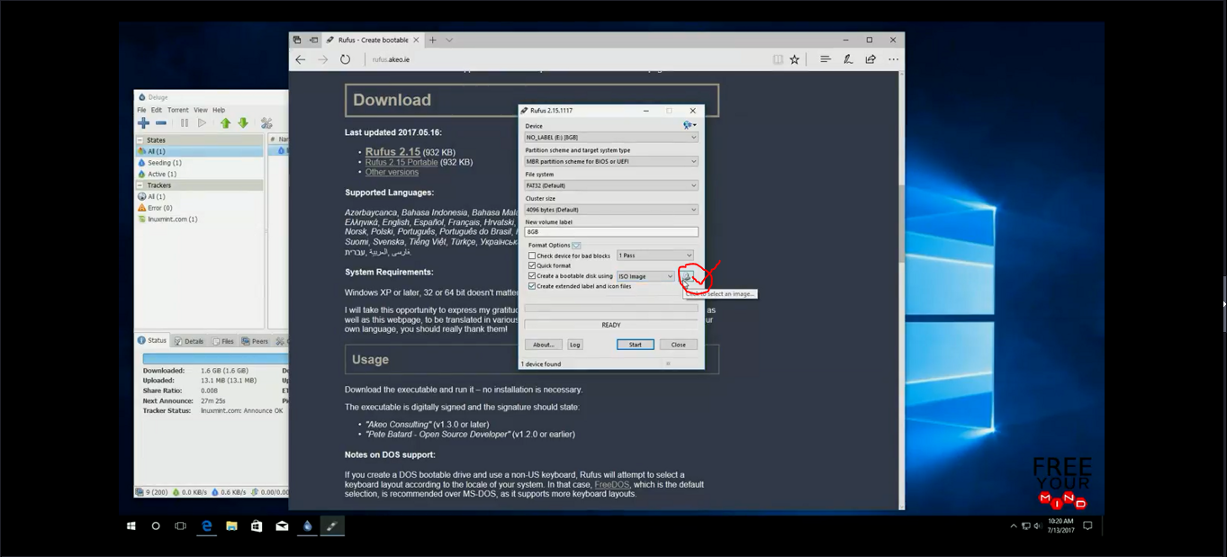
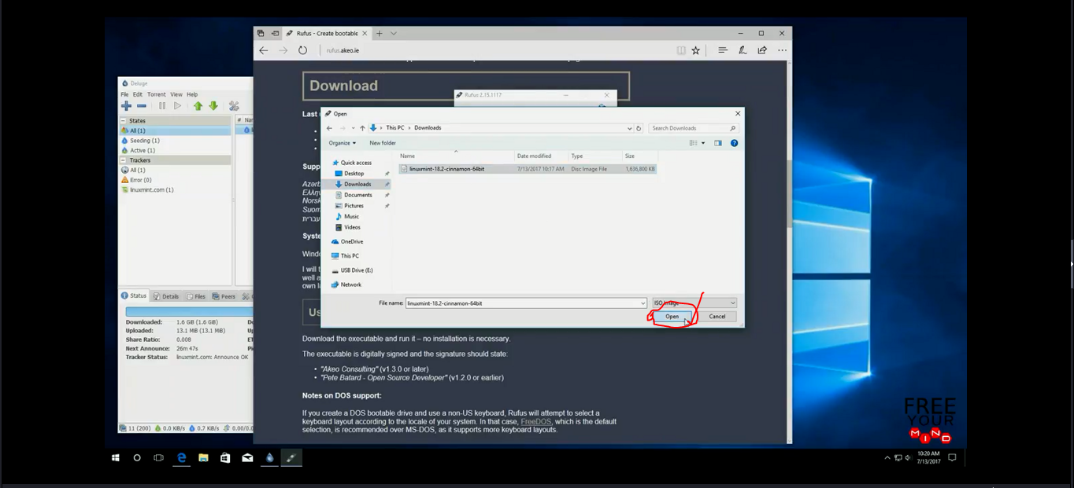
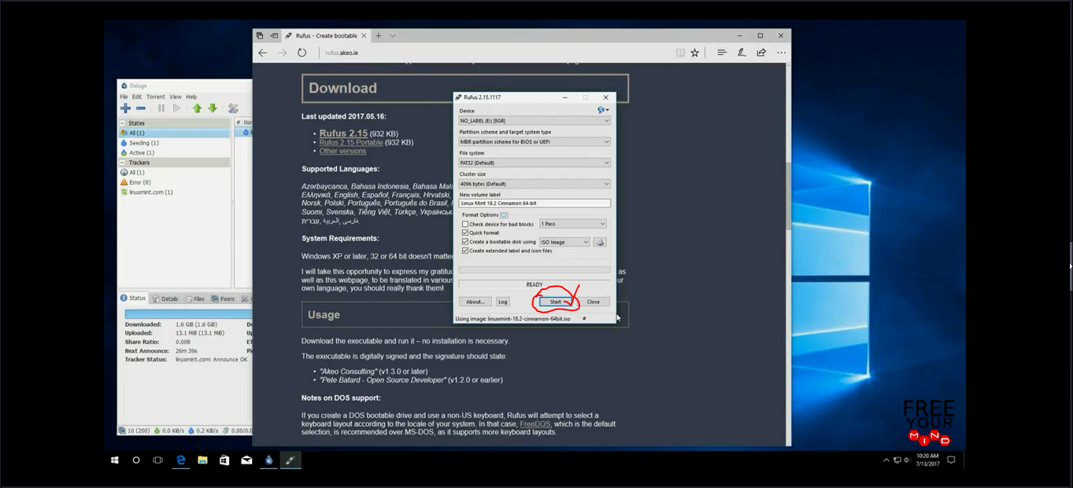
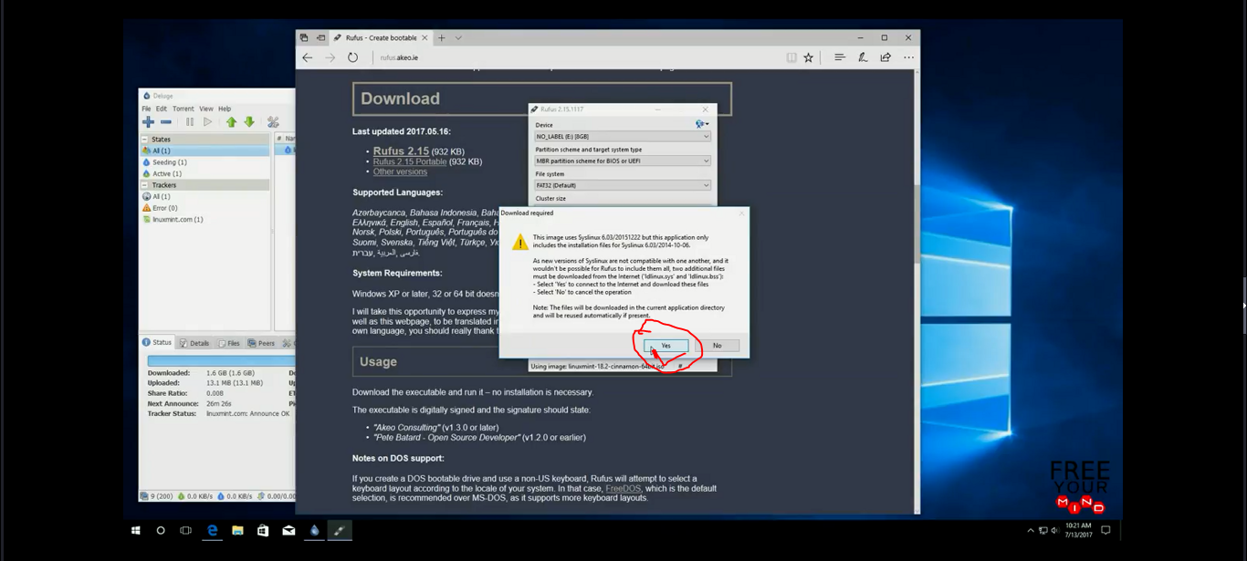
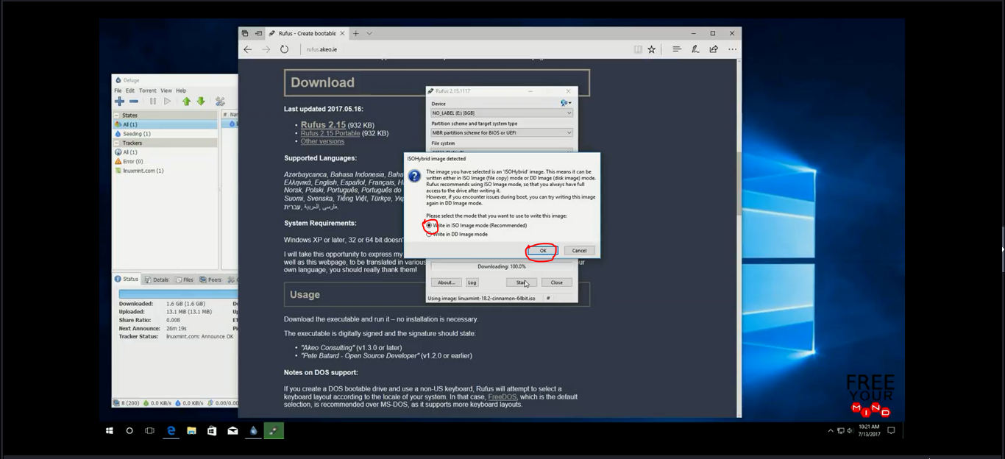
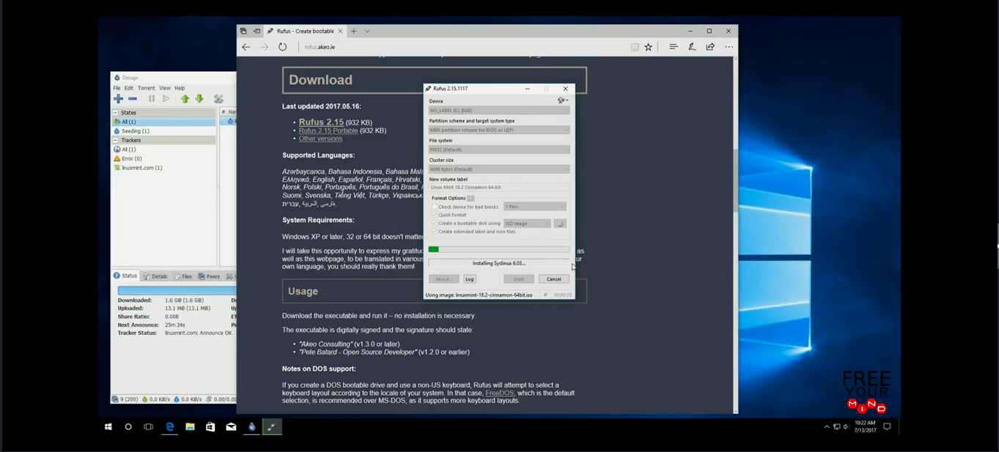

Step 04:
Boot Linux-Mint From USB .
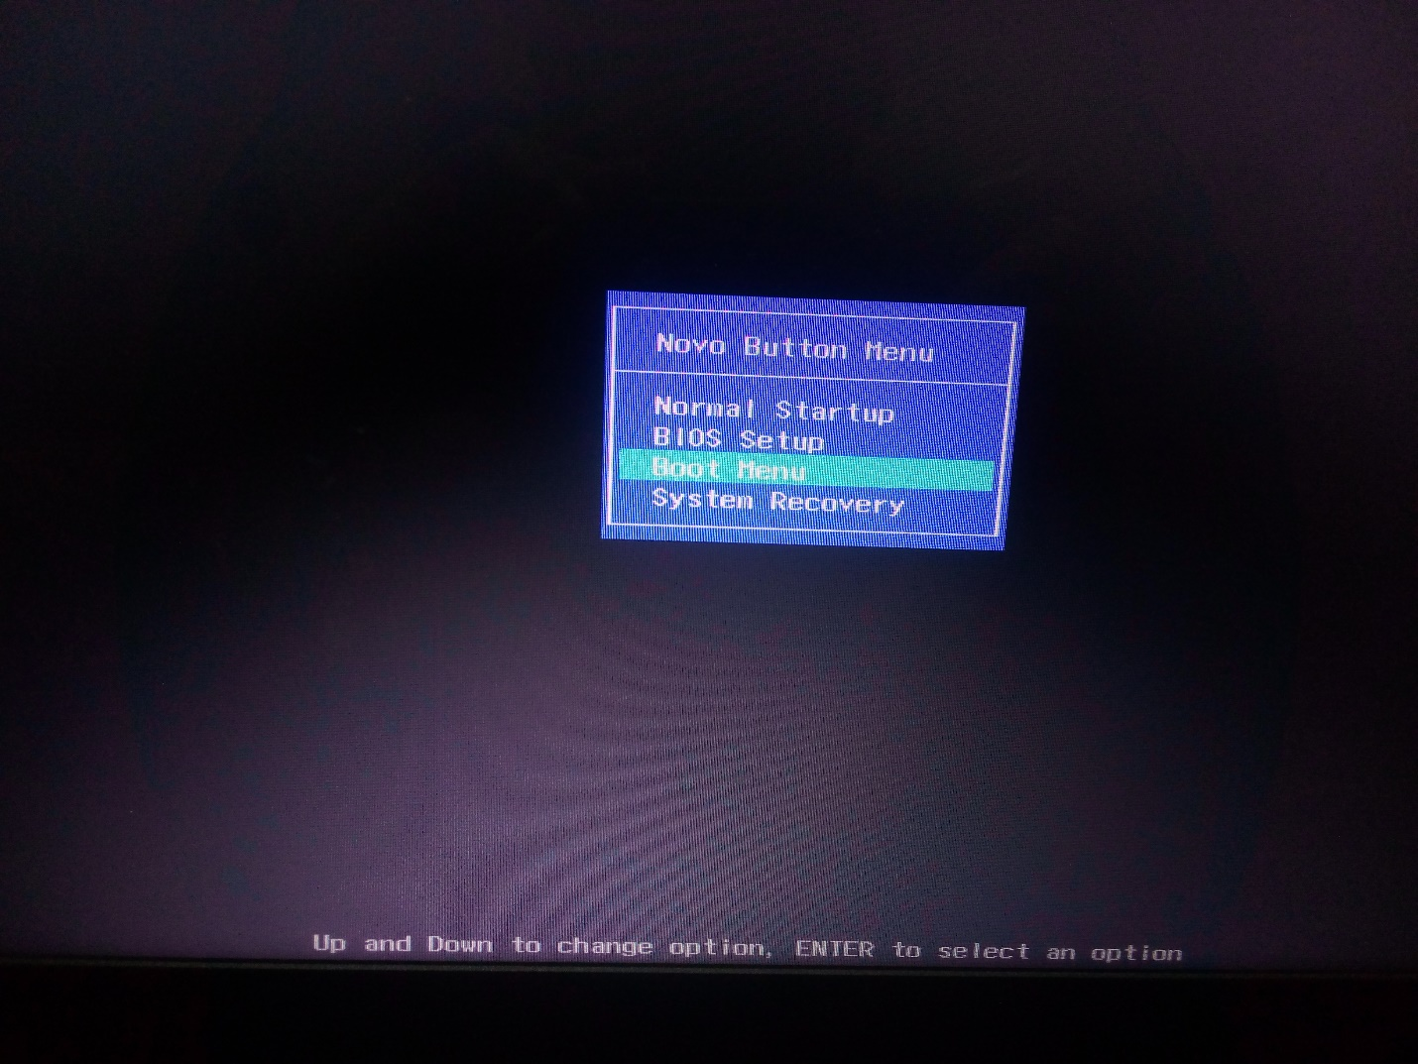
Press enter button.
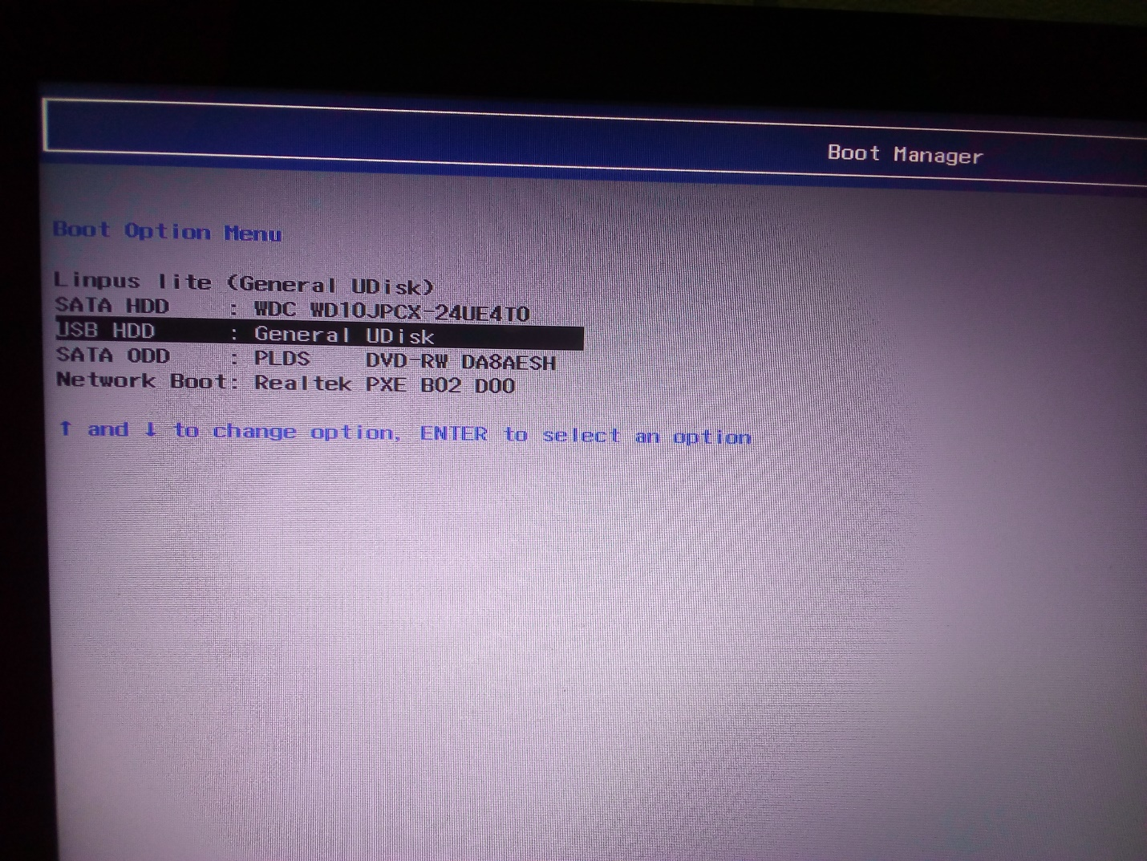

Again press Enter.

Step 05: Install Linux-ubuntu
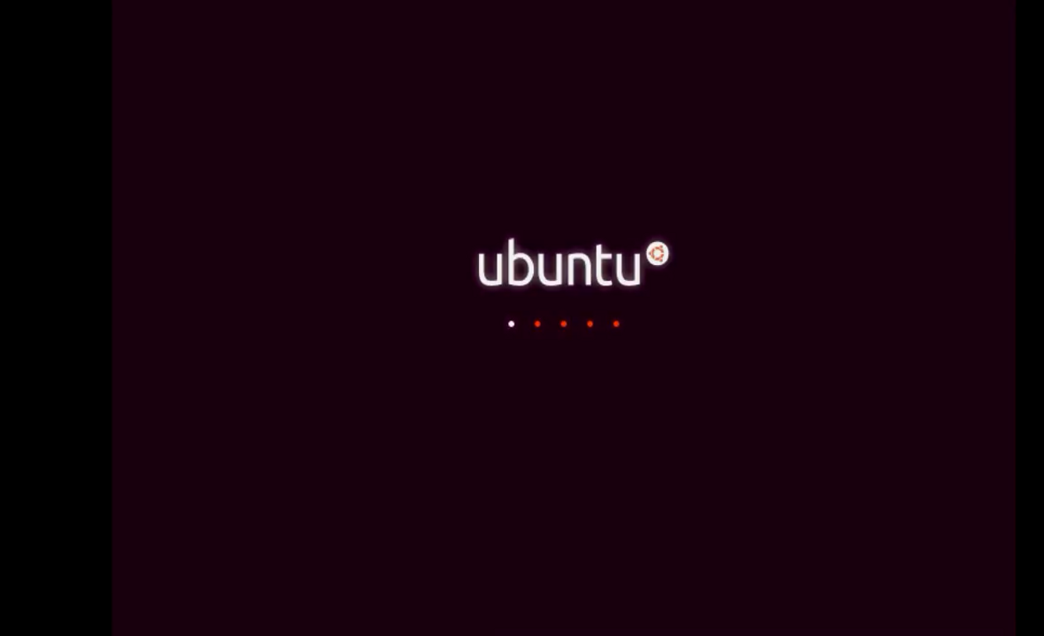
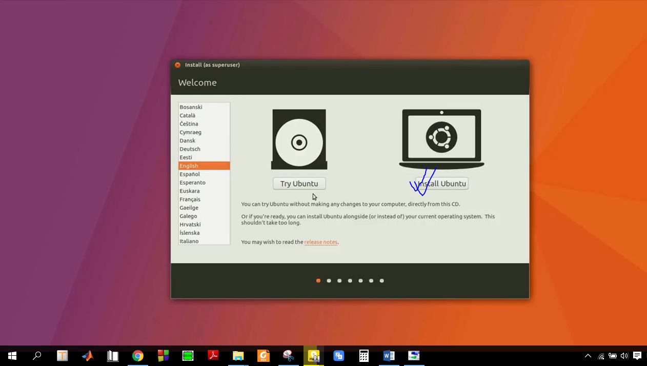
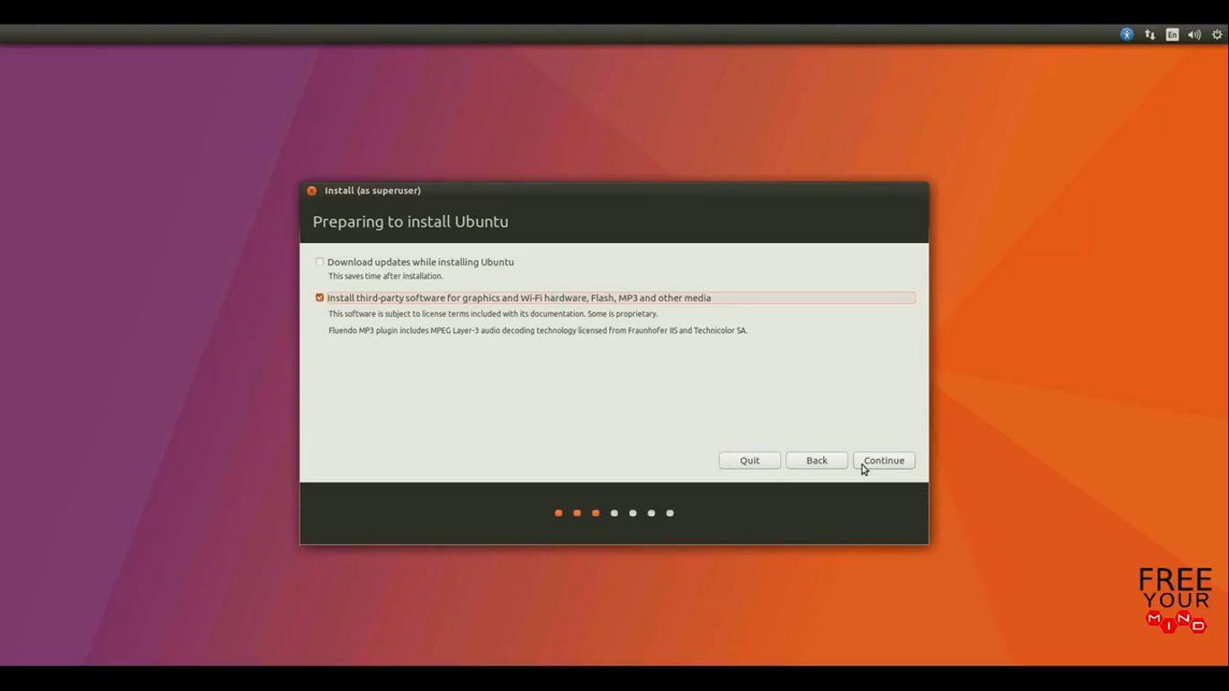
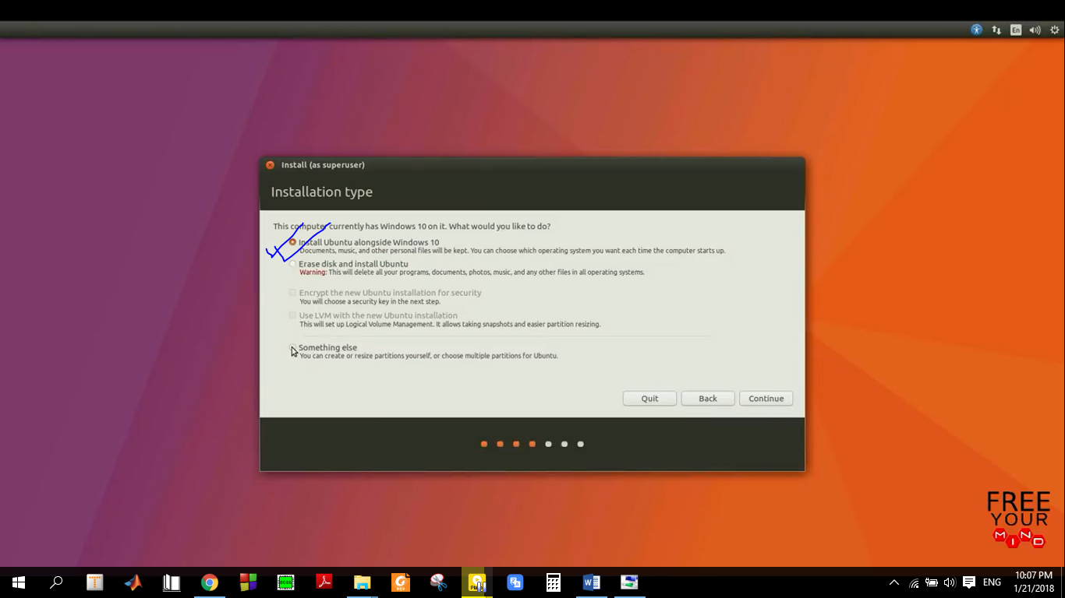
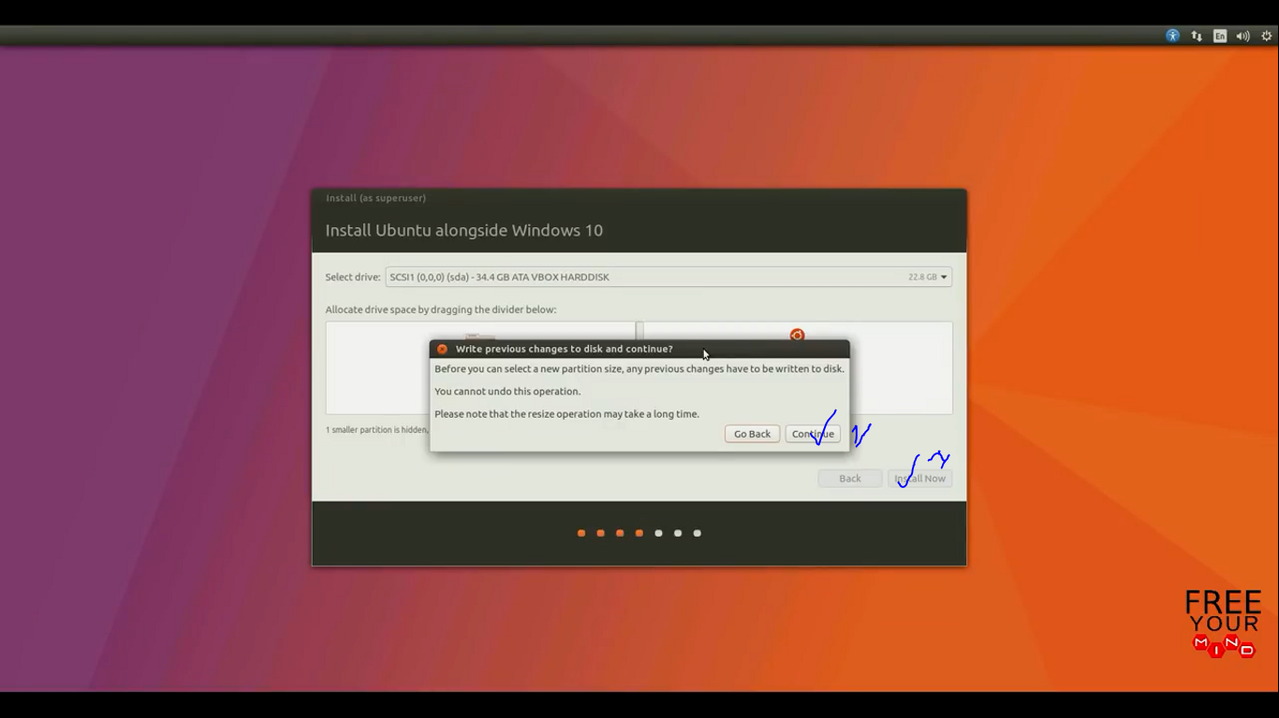
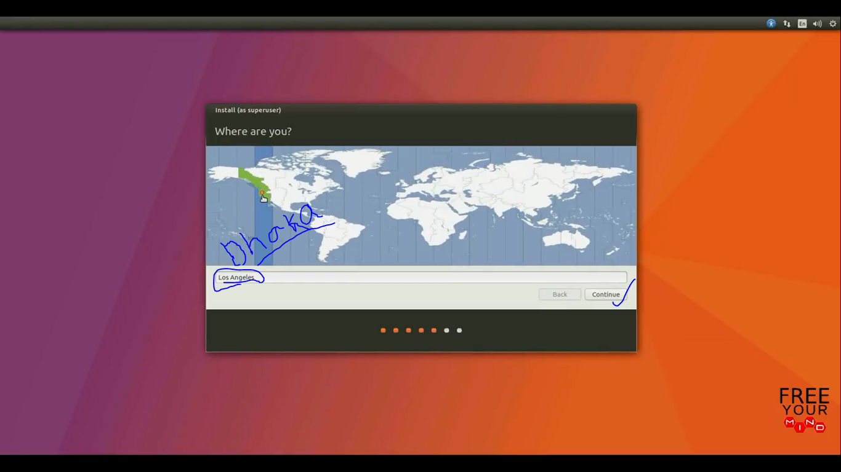
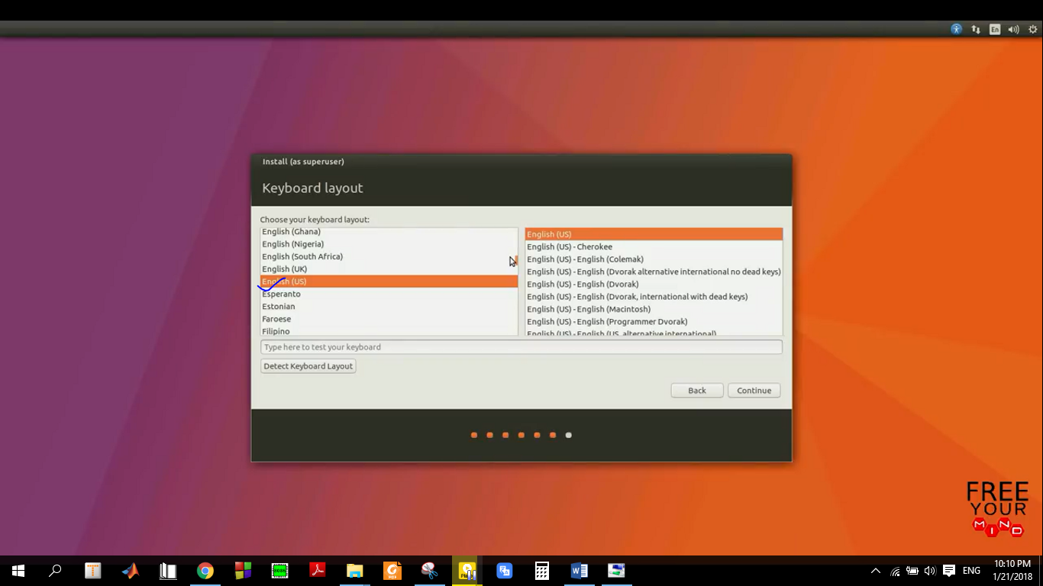
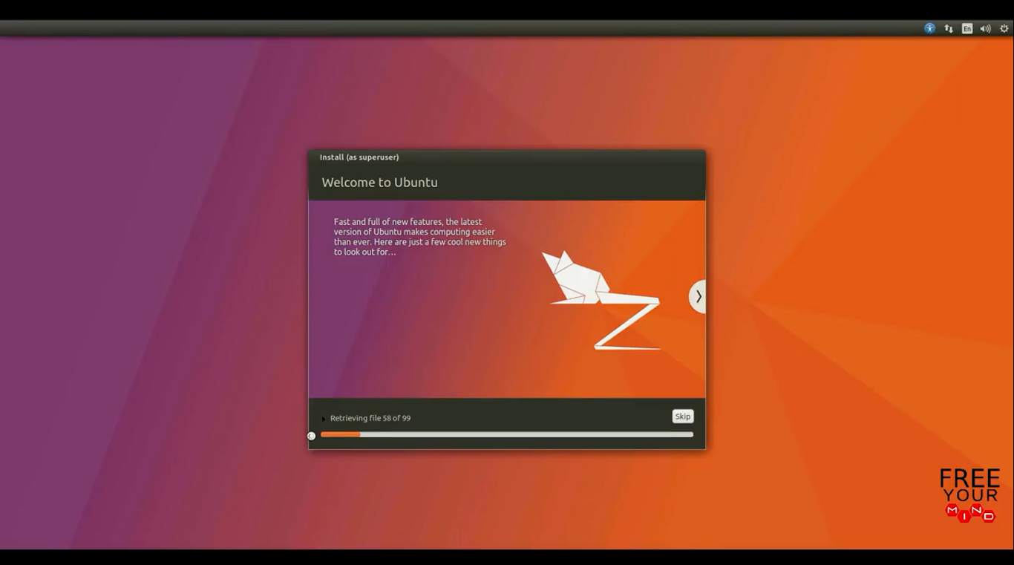
Conclusion: Finally i install the linux from the help of online video and different blog . Actually it is Linux-mint 18.2 ‘Sonya’ cinnamon.

